Detailed Project Design of CS229

Summary

First a baseline will be built using a simple CNN model to identify the gradients of the dish image. Some core components will be set up for this purpose. After mid-checkpoint, more advanced models and functionalities will be iterated upon depending on the timeline.

Design

For the baseline model, we will start with a simple CNN

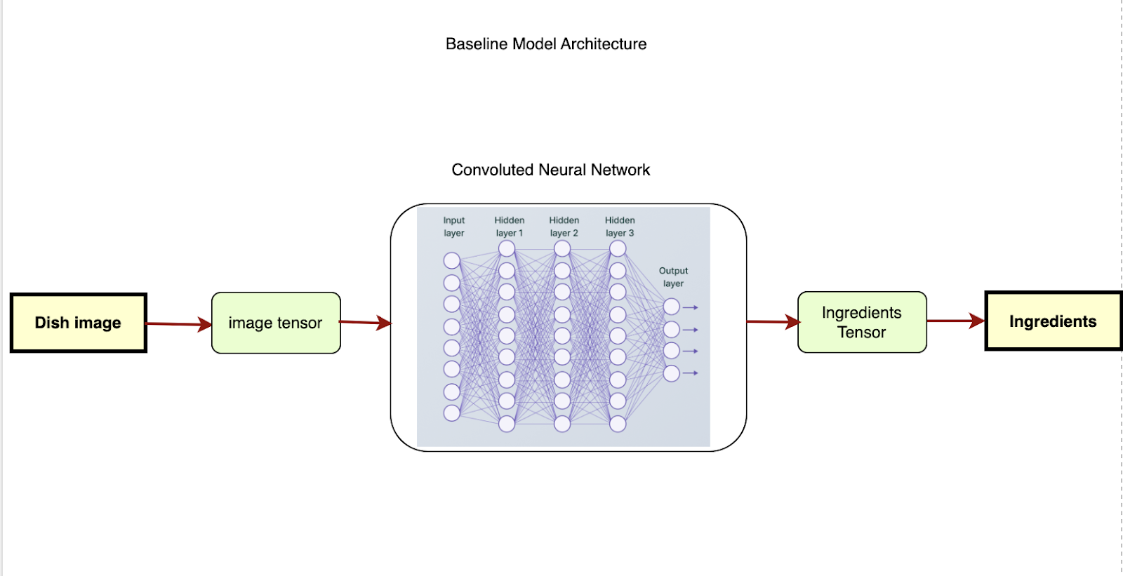

Tasks

1. Download dataset
   1. Confirm the validity of data source
   2. Develop script to download the dataset
2. For the model, there are a couple of approaches
   1. Use ResNet
      1. No much work
   2. Use built-in lib to construct the CNN
      1. Less than 100 lines,
      2. Lots of testing scenarios
      3. Fine tuning
3. Set up pre-trained model for reference (optional)